
- Initialize an array key of size n where key[i] represents the minimum weight of an edge connecting vertex i to the current MST Initialize all elements of key to positive infinity except for the first vertex which is set to 0
- Initialize an array mstSet of size n where mstSet[i] is true if vertex i is included in the MST and false otherwise Initialize all elements of mstSet to false
- Repeat the following steps n times
  - Find the vertex u with the minimum key value such that mstSet[u] is false This can be done in O(n) time by iterating through all vertices
  - Include vertex u in the MST by setting mstSet[u] to true
  - Update the key values of all adjacent vertices v of u if mstSet[v] is false and the weight of the edge between u and v is smaller than the current key[v] value.

- Read Input: Parse the input file to build the graph Each line contains from to and weight representing an edge between two vertices and its weight
- Algorithm: To find the maximum spanning tree we can use Kruskal’s algorithm with a max-heap
- Initialize: Sort edges in descending order of weights or use a max-heap to process edges from highest to lowest weight Initialize a union-find data structure to track connected components
- Process Edges: For each edge in descending order check if the vertices of the edge are in different components using the union-find structure If they are add this edge to the MST and union the two components
- Output: Print each edge in the resulting MST which represents the maximum spanning tree
Running Time: The running time is O(mlog m) where m is the number of edges due to sorting or max-heap operations

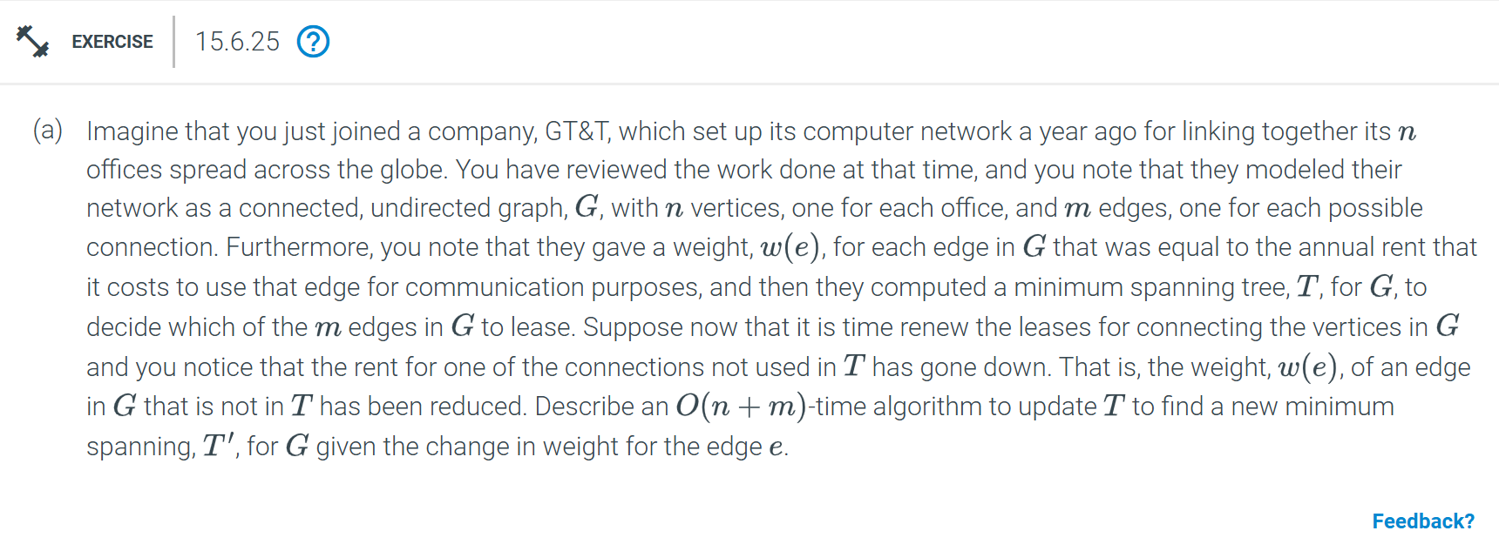
- Check if adding the edge e with reduced weight creates a cycle in the current minimum spanning tree T
- If adding e does not create a cycle then add e to T and T' = T is already a minimum spanning tree
- If adding e creates a cycle identify the edge in this cycle with the highest weight
- Remove this highest-weight edge from T to break the cycle and form a new tree T'
- The resulting tree T' is the updated minimum spanning tree
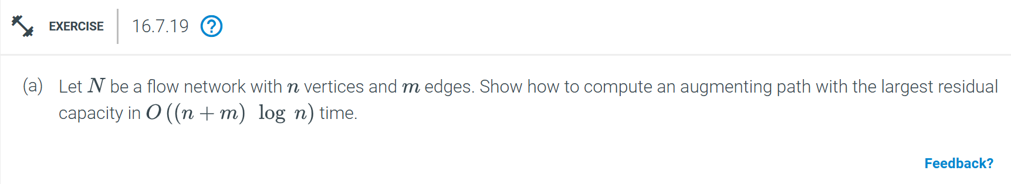

- Initialize all vertices with a residual capacity of zero except for the source vertex which is set to infinity
- Use a priority queue to implement Dijkstra's algorithm with the following modifications:
  - For each vertex u, extract the vertex with the highest residual capacity from the priority queue
  - For each edge (u, v) in the residual graph update v’s residual capacity to be the maximum of its current capacity and the mini mum of u's capacity and the edge's residual capacity
  - If v ’s residual capacity is updated insert or update v in the priority queue with this new capacity
- Continue this process until reaching the sink or the priority queue is empty
Running Time: The time complexity is O((n + m)log n) due to the priority queue operation

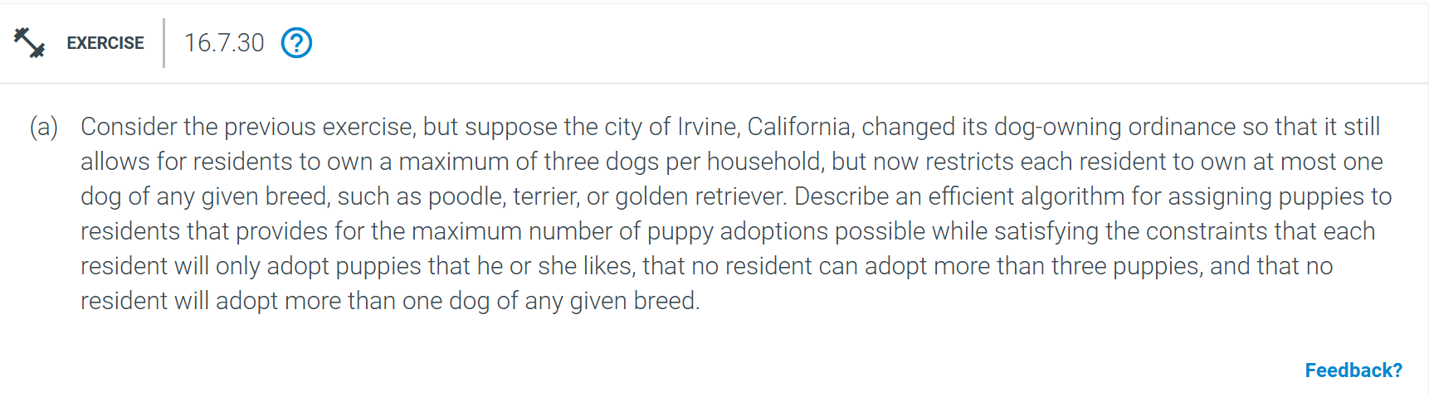
- Model the problem as a flow network with the following structure
- Create a source node and connect it to each puppy with an edge of capacity 1 representing that each puppy can only be adopted once
- Create a sink node and connect each resident to the sink with an edge of capacity 3 representing the maximum of three dogs per resident
- For each puppy create an edge from the puppy to each resident who likes it with a capacity of 1
- Add a constraint for each breed by ensuring that for each resident there is an intermediate noe for each breed they like connecting this breed node to the resident with capacity 1 This enforces the rule of one dog per breed per resident
- Use a maximum flow algorithm to find the maximum matching from source to sink which gives the maximum number of puppy adoptions satisfying all constraints
Running Time: The running time is O((n + m)^2) due to the flow algorithm


- Model the problem as a minimum-cost bipartite matching problem with limos on one side and pickup locations on the other
- Create an n x n cost matrix where each entry dij represents the distance from limo i to location j
- Use the Hungarian algorithm on this cost matrix to find the optimal matching between limos and locations that minimizes the total distance
Running Time: The running time of the Hungarian algorithm is O(n^3)

